

**Equity Valuation Report**

**Analysis Report**

**VOLVO GROUP**

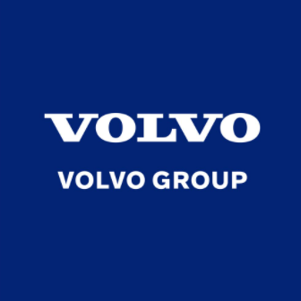

**MBA 906**

**Financial Strategy and Governance**

**Submitted To :** Dr. Kashif Saleem

**Students Name :** Unaza Naveed, Samiheh Mohammad Nasiri, Mohamad Rashid Obaid Almheiri,

Bowen Jin, Karthikeya Nalluri

**Student Ids :** 6865045, 6862640, 6696041, 4793687, 6865653

**Email Ids :** [un184@uowmail.edu.au](mailto:un184@uowmail.edu.au), sn813[@uowmail.edu.au](mailto:@uowmail.edu.au), mroba610@uowmail.edu.au

[bj419@uowmail.edu.au](mailto:bj419@uowmail.edu.au), [kn474@uowmail.edu.au](mailto:kn474@uowmail.edu.au)

**Submission Date: 23rd April 2021**

**Executive Summary**

Volvo Group in one of the leading Swedish multinational manufacturing company with a mission of driving prosperity through transport and infrastructure solutions. The company is manufacturing products and services which are 100% safe, fossil-free and more productive so to drive prosperity socially, environmentally and financially as well. Volvo group is the world’s second largest manufacturer of heavy-duty trucks as the trucks classified as light, medium and heavy duty based on their load capacity. It’s the world leading manufacturer of the buses, trucks, and construction equipments, marine and industrial engines. To become the second largest manufacturer of heavy-duty trucks in the world the group sets their clear direction to achieve the sustainable development goals. To lead towards the high distribution of trucks they mainly focus towards the volume flexibility with the cost reduction.

As a “Stock Analyst” we are assigned to prepare an “Equity Valuation Report” based on our valuations and ratio analysis it is unlikely that the growth rates will be higher than the forecasted EPS growth rates. In fact, the year-over-year growth in the industry globally is only about 18.80% Furthermore, the growth rate in 2021 and beyond is going to be significantly reduced due to the economic impacts of the COVID-19 pandemic. Taking the above factors into account, it is fair to assume that the company will be able to provide shareholders with a substantial capital gain for their equity investment in the future as the decrease in their Operating Margin of 8.4% despite of decline in the sales of 22% with focus on sustainability goals.

Volvo Group has the highest Net Sales in Europe Market with 40% and by segment in Trucks with 61% **.**They performed well in managing the Covid-19 impact by having a focus on volumne and cost flexibility. Their main competitors are Daimler with 42.54 billion US dollars whereas Scania comes on the third with 20.44 billion US dollars revenue Paccar comes on the fourth level competitor with 17.15 billion US dollars revenue. We recommend to the existing shareholders to buy/hold the shares for the long – term investment gains with the WACC of 5.165% even though the price per share is overvalued.

**Table of Contents**

**Recommendations** **3**

**Business Description** **4**

**Industry Overview and Competitive Positioning** **5**

* SWOT Analysis**6**
* Porter’s Five Forces **7**
* PESTEL Analysis **8**

**Investment Summary-Financial Analysis** **9**

**Valuation** **11**

* Discounted Cash Flow **12**
* Price Relative Estimates **12**
* Sensitivity Analysis. **13**

**Investment Risks** **14**

* Operational Risks **14**
* Compliance Risks **14**
* Financial Risks **14**
* Strategic Risks **15**
* Covid Risk **15**

**Risk Management Strategy** **16**

**Corporate Governance - CSR** **16**

**Scenario Analysis** **17**

**Appendix** **18**

**References** **23**

**BUY/HOLD**

**Market price 216.5**

**Valuation Price 211.75**

**Ticker VOLV-B.ST**

**52-WEEK HIGH 240.8**

**52-WEEK LOW 113.7**

**Market Cap. 427.56 B**

**Shares Outstanding 2.03B**

**Free Float 56.40%**

**Exchange Stockholm Stock Exchange**

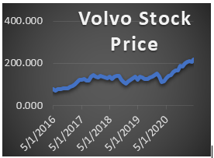

# **Recommendations**

**Investment Scenario:** Their share is currently overpriced and current market conditions because of Covid does not favor a significant increase in share price for the near future leads to decrease in growth as well. Even though their price per share is overvalued but still we recommend the “buy/hold” recommendation as the company is expected to have bounce back in their growth and investments should not be done for the short term gains else they needs to done for the long-term scenarios.

**Transformation to electrification leads to increase in revenues:** Capital markets to focus on strong position in electrification as transformation leads to growth in market share and will increase the revenues by more than 50%.

**Diversified Product portfolio:** The company need to diversify their product portfolio as demand for their products is highly correlated with the market conditions 61% of their revenues comes from the trucks.

**Business transformation by reducing cost:** The group needs to sell out that legacy property which is not generating revenues continuously and use that amount for the purchase or acquisition of other profitable businesses with a human –centered approach rather just focusing on workforce redundancy.

**Focus on recovered markets of Covid 19:** The company needs to consider the increase in their revenues by focusing on those countries such as Asia Pacific, China from pandemic state.

|  |  |  |
| --- | --- | --- |
| **Figure 1:Revenue By Market**    Source: Volvo Group Annual Report  **Figure 2:Revenue By Market**    Source: Volvo Group Annual Report | **Business Description**  Founded in 1927 in Sweden, it’s the second largest world manufacturer of heavy-duty trucks. The core activities of the company is the production, sale and distribution of the buses, trucks and equipment’s of construction whereas it also supplies industrial and marine drive systems and financial services as well. Inorder to become the customer’s top choice always prefer a trustful relationship in a business-to-business market.  It has employed 100,000 people and providing production facilities in 18 countries with the coverage of 190 markets. With the four important business lines on the road, at the site, in the city and at sea their products are involved in many of the functions that most of the people rely on everyday life. Volvo Group with a Net Sales of SEK 338 billion has 12 strong brands and 10 important business areas including Volvo trucks, Volvo Penta, Volvo Construction Equipments, Volvo Buses, Volvo Financial Services, Volvo Autonomous Solutions, Renault trucks, UD trucks & JVs, Volvo Energy, Arquus to reach the different market segments and the customers for the market growth.  Volvo Group to stay at the forefront is having a partnership with Samsung SDI for battery packs of trucks, Joint venture with Daimler Trucks for fuel cell systems and an agreement with NVIDIA for autonomous commercial vehicles. By the end of 2020 the Group is having the highest Net Sales by market in Europe Market with 40% **(Figure 1)** and the highest Net Sales by segment in Trucks with 61% **(Figure 2).**Volvo Group despite having a tough year has performed well in managing the covid-19 impact by having a strong execution on volumne and cost flexibility and by having a decrease in the Operating Margin of 8.4% despite of decline in the sales of 22% with focus on sustainability **(see Appendix 4).** | |
| **Figure 3:Revenues of 2020**    Source: Volvo Group Annual Report  **Figure 4:Revenues of Volvo Group**  **Competitors**    Source: Statista.com  **Figure 5:Market share in Heavy-duty**  **Trucks**    Source: Volvo Group Annual Report  **Figure 6:Major Shareholders**    Source: Volvo Group.com | **Industry Overview and Competitive Positioning**  Volvo group trucks performance is correlated with the economic conditions as well as the industry progress so the revenues of the trucks are highly effected during the period of recession. Changes in the prices of the raw material impact their prices whereas oil prices and the infrastructure also impact the sales of the industry **(Figure 3)**.  **Second largest heavy-duty trucks Manufacturer**  Whereas Daimler with 42.54 billion US dollars revenue is the top competitor of Volvo Group in trucks whereas Scania comes on the third one competitor of Volvo with 20.44 billion US dollars revenue and Paccar comes on the fourth level competitor with 17.15 billion US dollars revenue of Volvo group **(Figure 4).**  **Highest Market Share in Heavy-Duty Trucks**  Heavy-duty trucks have the highest market share in Europe with 25% and the second in Brazil with22.2% **(Figure 5).**They are having the three truck divisions having Group Trucks Technology, Group Trucks Operation, Group Trucks Purchasing.  **Industry Electrification for Sustainability**  The company bring the driving industry towards electrification through selling of electric trucks from 2019 to bring electromobility for the long term sustainability with zero emissions of gases. They are having a strong market in Europe and North America for the electric trucks from Volvo trucks, Renault trucks, Volvo VNR trucks and Mack trucks. For the fuel-cells to be used in heavy-duty trucks they are having a joint venture with Daimler Trucks for the large scale of its production to improve the energy efficiency.  **As a leading Brand**  Volvo group has started many initiatives to 100% fulfill its ambition of fossil-fuel trucks to have a positive impact on the society till 2040 such as UV trucks launches “Fujin & Raijin-Vision 2030” which acts as road map to led towards the electric and autonomous truck for the reduction of C02 emission.  **Leading Prosperity for Stakeholders**  Volvo group take great care of the uptime and profitability of their customers by providing solutions to boost their performance. They have SEK17.8 billion of contribution towards the society in the form of taxes and social costs. They proposes SEK 30.5 billion dividends for the shareholders of the company **(Figure 6).**  **Going green Industry**  For the investment for the clean transportation in 2020 Volvo group launched the Green Finance Framework. They took initiative of Paris Climate Agreement with ambitions to become a zero emission company till 2050 and to take Science Based Targets Initiatives. |

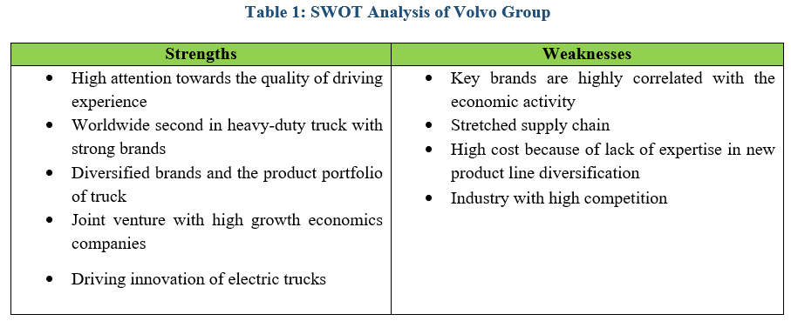

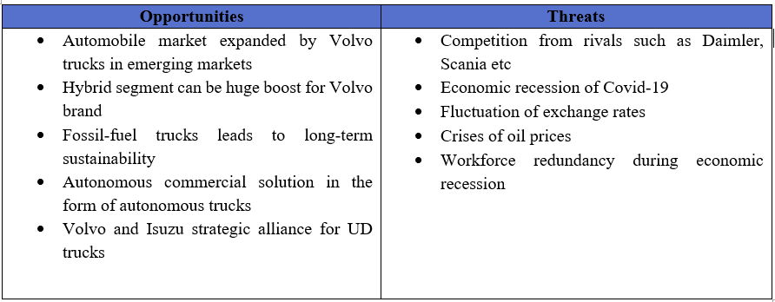

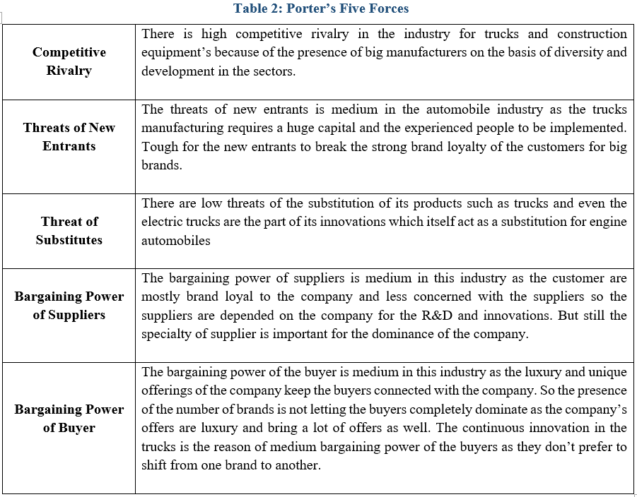

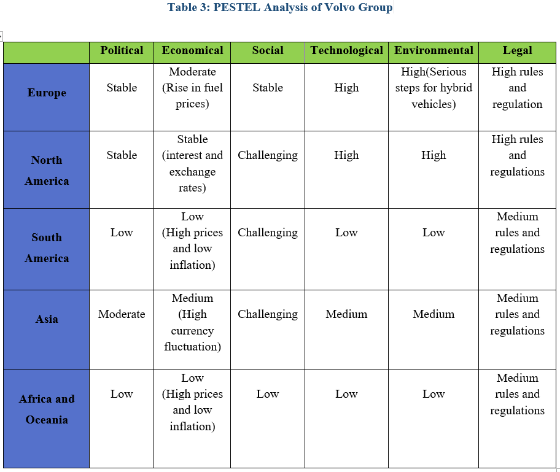

|  |  |
| --- | --- |
| **Figure 7:Profitability (Excel sheet)**    Source: Volvo Group Annual Report  **Figure 8:Leverage (Excel sheet)**    Source: Volvo Group Annual Report | **Investment Summary – Financial Analysis**  **Stable Business Tatics, Revenue and Profitability**  According worldwide area Europe was one of best buyers of truck and they had high amount of sale in that area in 2019 but because of pandemic and covid19 they had declined in 2020 but still they are stable and had coverage of sale in beginning of 2021 year. For Volvo group, ROA had reduction from 14.40% in 2020 and 18.92% in 2019 because of Pandemic in worldwide but still acceptable because it is around 5% reduction but in another way was interesting Volvo group had increase in 2020 in earning ratio 20.4% in compare with 2019 with 8.9%. That’s mean still have good return of asset and equity for shareholder **(Figure 7).**  **Strong Cash Flow in Sweden and Europe**  In 2020 quick ratio 1.22% that is more than 2019 of amount of 1.16% and also current ratio in 2020 with amount of 1.47% and 2019 with amount1.45% and almost same value they have which means that a company is able to meet its short-term obligations and good amount in liquidity amount in during that two years and they put more in operational activities.It shows high asset and dividend in world especially in Sweden and Europe. According to cash flow statement that have higher amount of operation cash flow and 30610 SEKM with comparison of financial and investing activities.  **Good Future Value, Growth and Reducing Risk**  In operational line company are in good position of financing and stable in time interest coverage. According of leverage ratio Volvo group had 4% higher equity in 2020 if we compare in 2019 but in 2020 they was not successful in interest coverage and debt ratio and they had decline in both line but they had good ratio in self-financing in 2020 with amount 279% that is more than 2019 with amount 265 %.That ratio analysis will show us with pandemic and reducing in gross income still company have in good place and can make more cover in new year and can add some facility in their business in line of transportation to make more sale in 2021. |

**Table 4: Ratio Analysis**

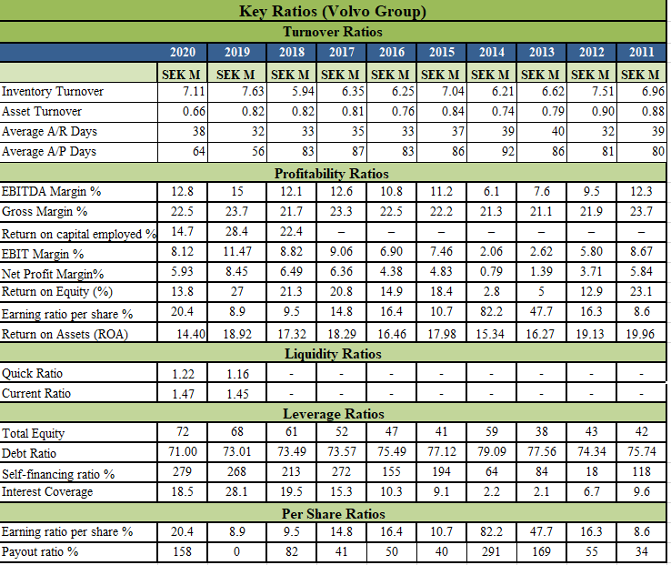

|  |  |
| --- | --- |
| **Table 5:Valuation Assumptions**    **Table 6: Growth Rate**    **Table 7:Free Cash Flow** | **Valuation**  **Discounted Cash Flow**  The DCF is calculated using a WACC of 5.165% **(Table 5).** The Euribor of 3 months is considered as Risk free interest rate and it is assumed to 0.00%. The cost of equity is calculated by considering the Beta of 1.332 and Risk premium by considering the ‘Country Defaults Spreads and Risk Premiums’ by Aswath Damodaran website. The cost of Equity is calculated to be 6.29%. The cost of Debt is calculated by considering total interest expense and the total current and non-current debt (Bond loans and other loans) and is calculated to be 2.50% the growth is calculated by considering the revenues and the terminal Free cash flows are expected to grow at a standard rate of 2.62% **(Table 6).** The intrinsic value by DCF valuation is 211.75 SEK **(Table 7, 8)** **(see Appendix 5, 6, 7, 8).**  **Table 8: DCF Model**    **Price Relative Estimates**  We compare Volvo with other companies, and we find that because the overall valuation of the automotive industry is high, Volvo's valuation is reasonable. We compared Daimler, Scania, PACCAR which also produced trucks, and we found that Volvo's P/E and EV/EBITDA are reasonable. Furthermore, Volvo's P/B and ROE are similar to the entire automotive industry.Method of analyzing stock price through price-earnings ratio (PE) **(Table 9).** |

**Table 9: Price Relative Estimates**

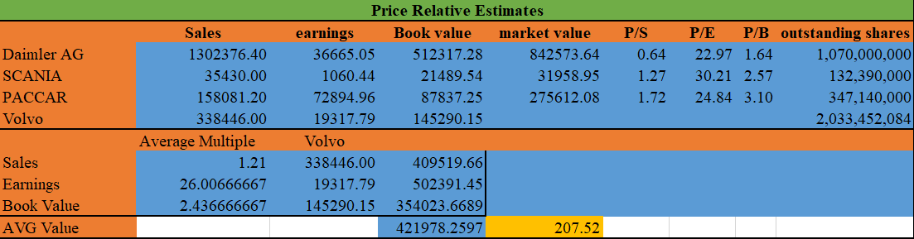

|  |  |
| --- | --- |
|  | **Sensitivity Analysis**  Volvo's final value accounts for 97.8% of the company's value which is a good signal to investors, means that the company's valuation is not overvalued. Consider that the market price of the stock will be higher than the actual price. It’s a good choice for investors to continue to hold/buy stocks. We conducted a sensitivity analysis, and we observed the impact of WACC and growth rate on DCF. We think our buy/hold recommendation should not be influenced by WACC increase or decline in growth rate of Volvo. **(Table 11).** |

**Table 11: Weighted Average Cost of Capital**

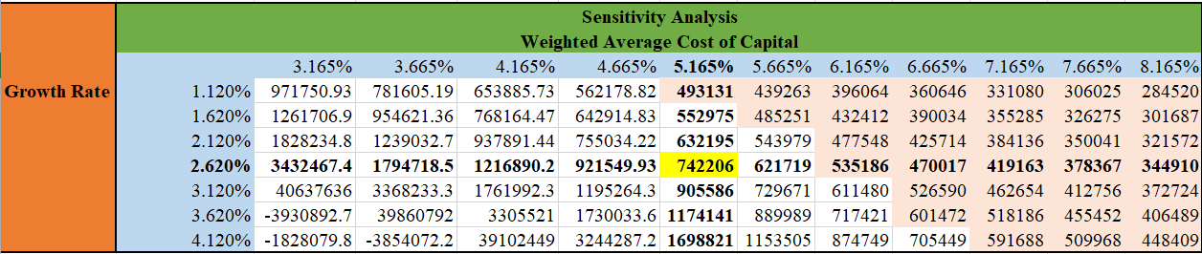

|  |  |
| --- | --- |
|  | **Investment Risks**  **Operational Risks**  **Customer’s Demand Satisfaction:** Now a day’s customer’s demand for a sustainable products which act as great risk for the company revenues is their experience is not at the expected level.  **Cyclical Vehicle Industry:** The vehicle industry is strongly linked with the GDP and the demand for transport as well as changing laws. The Volvo group needs to react quickly with the market changes to reduce the fluctuating demand risk for its products and services  **Political Instability:** Political instability has direct impact on the group’s trade ability as its operating in 190 countries such as the ongoing trade discussion between USA and China and the Brexit process leads to rise in tariffs and other trade barriers will negatively impact the Group’s progress.  **Compliance Risks**  **Data Protection Laws non-compliance:** Volvo group needs to follow the data protection laws according to as non-compliance will lead them towards the heavy penalties.  **Legal Proceedings:** Volvo group legal proceedings may include vehicle safety, warranty claims, commercial disputes, intellectual property claims like are quiet expensive and take up the resources that can be used for the other purposes. There is no assurance that the provision for any particular legal proceeding will cover the cost of an adverse outcome.  **Non-compliance with competition law:** Volvo group has high potential risk of non-compliance with competition law such as price fixing, market sharing and abuse of market power. It has sever negative impacts for the reputation of the company.  **Financial Risks**  **Credit Risk**: The company has borrowed money with fixed rate of interest and liable to repay the interest component irrespective of standard benchmark rate as well as it has credit risk related through its sales to customers and long –term credit receivable in its financial services.  **Commodity Price Risk**: The increase in commodity price in global market will impact the cash flow of the company and net earnings such as increase in the prices of oil.  **Transection Exposure (Currency) Risk**: The Volvo group reports its financial statements in SEK, and exposed to the transaction exposure risk from the cashflows from operation in other currencies. The exposure is determined through the sales to purchase in different currencies and 95% of the Volvo group sales are generated through other countries.  **Strategic Risks**  **Shift of Technology:** Lack of acceptance of the technology act as a great risk for the Volvo group as they need to choose the relevant technology, at the right time and for the right market to be targeted.  **IT infrastructure:** Volvo group all processes depend upon a strong IT infrastructure for their production, sales, connectivity and automation so any kind of threats act as a great risk for the repetation of the company  **Labour Shortage:** The labour shortages of the trucking industry will directly impact the production level of the Volvo Group.  **Covid Risk**  The Covid-19 has a significant impact on people, business and societies across the globe. The Covid relate risk includes closure of plants, decrease in sales, restrictions in movements due to lockdown and remote work impacting the business operations. The company as impacted by lower in demand during the first half of 2020 financial year along with the disruption in supply chain. Due to its prolonged duration Volvo group faces financial difficulties by the key suppliers, disruption of supply chain, high price pressure on the used and new vehicles, Intangible assets and the goodwill of the group impairments and sever problems of the financial markets.  **Risk Management Strategy**  Volvo group follows different hedging strategy to mitigate the business and investment risks.  **Fair value hedge**: The group hedges the variability of fixed rate debt from changes in the benchmark yield curve by converting the fixed interest rate into floating rare through interest rate swap.  **Net Investment hedge:** It hedged the investments made in foreign countries operation to minimize the value of net investment due to fluctuation in exchange change to ensure that the value remains same.  **Currency transaction hedge:** The currency transaction is managed by hedging around 80% of the future cash flow transaction in the 24 months and up to 60% of the transaction in the coming 25 to 48 months through different financial instruments option, forwards or combination of instruments with varied maturity time.  **Commodity price hedge:** Group’s procurement department manage the commodity price risk by executing the long term fixed price contract with the suppliers. Electricity is one of the major cost factor of the company. The company managed the fluctuation in the price of electricity by using the forward contracts.  **Covid risk Hedge:** It has implemented different measures as closure of temporary plants, adopting to new work environment in offices and factories, as well as introducing the work from home culture. The company availed grants related to Covid-19 amounting to SEK M 1013.  **Corporate Governance**  Volvo Group follows responsible business practices and good governance adhering to the guideline of Swedish law. The shareholders of the company are the highest decision-making body and body selects the board of directors of the company based on the suggestion on nomination committee to take the decision on dividends, company’s management, compensation and governance. The company has appointed Deloitte AB as its external auditor for external evaluation. Along with the audit committee the group has established other committees to manage the governance at the other organization’s functions product and investment strategy, people and sustainability committee, commercial transport committee, nomination committee, compliance & Ethics office.  The CSR is an integral part of Volvo group by following UN sustainability goals. The responsibility also includes to employee a workforce without having any gender bias, the company is committed to employ 30% of women leaders by 2030. The company has zero tolerance towards bribery and corruption and mitigate any sustainability risk through required due diligence, collaboration and building awareness. Volvo group focuses on various activities to engage with the society such as traffic safety and decrease in gas emission by electric vehicles, environment control, education. (Volvo group, 2021)  **Scenario Analysis**  Volvo group needs to have more mobility but they need to do that in a smarter way as their electric and autonomous trucks are working in a proper and safe environment. Their transport system needs to be enabled by an integrated cloud platform as the sensors of autonomous refuse trucks helps to react automatically to any potential incident.  The group is ready for the future to provide zero emission and low noise electric trucks that leads to the sustainable development even in the Covid-19 scenario. |

**Appendix**

**Appendix 1: Income Statement**

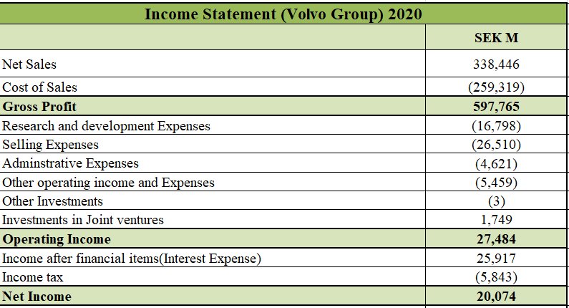

**Appendix 2: Balance sheet**

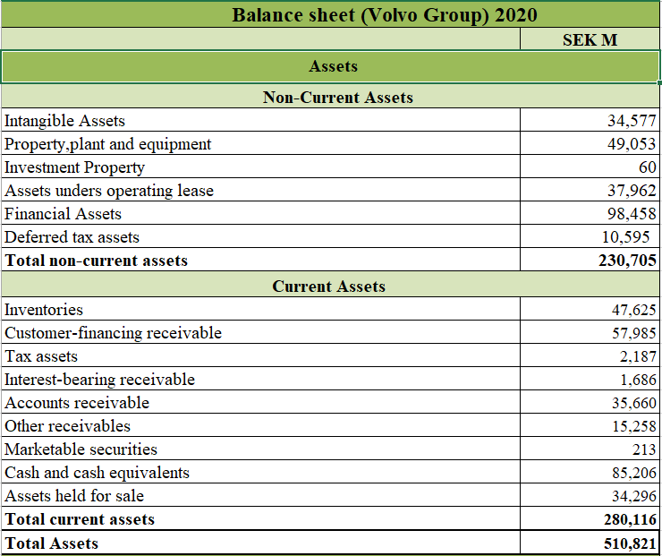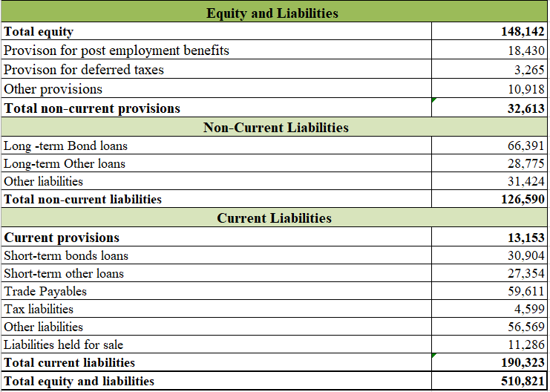

**Appendix 3: Cash Flow Statement**

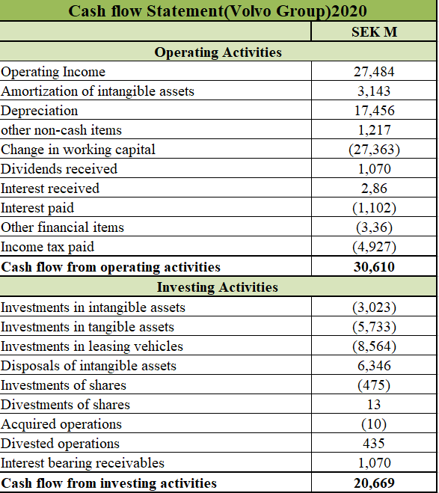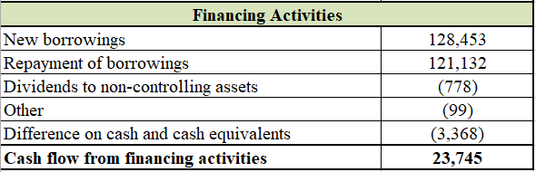

**Appendix 4: Clear Direction of Group**

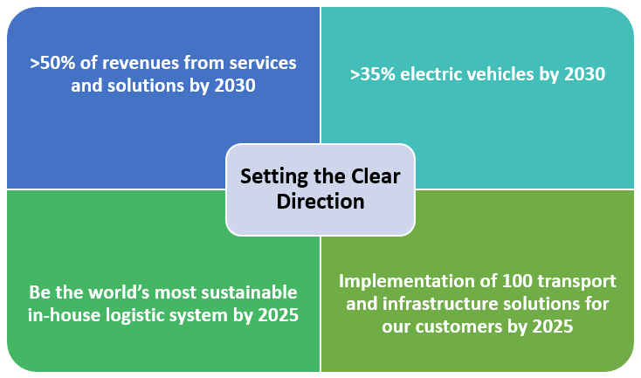

**Appendix 5: Cost of Equity**

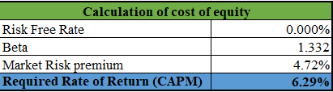

**Appendix 6: Cost of Debt**

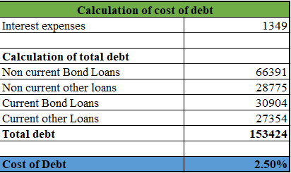

**Appendix 7: Value of Firm and WACC**

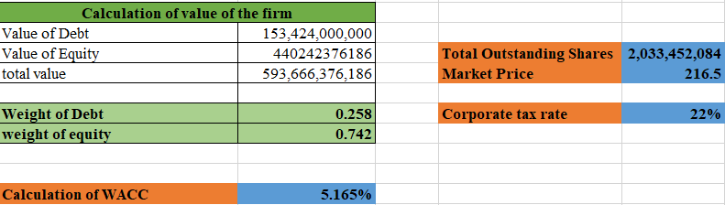

**Appendix 8: Interest Rates for Debt**

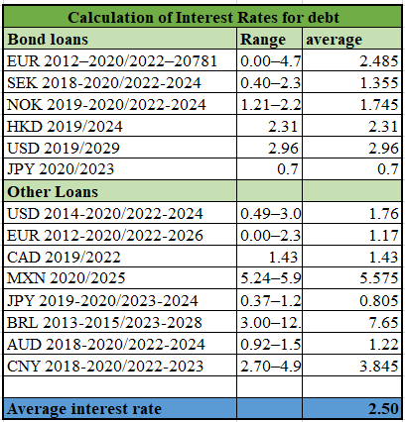

**References**

**1.** Statista. 2021. Largest truck manufacturers based on revenue 2020 | Statista. [online] Available at: <https://www.statista.com/statistics/270293/worldwide-leading-truck-manufacturers-based-on-production-figures/#:~:text=The%20world's%20largest%20truck%20manufacturers,a%20strategic%20alliance%20with%20Navistar.>[Accessed 18 April 2021].

**2.** Report, S., Inc., M. and Market Research Reports, I., 2021. South America PESTEL Analysis Market Research Report. [online] Market Research Reports® Inc. Available at: <https://www.marketresearchreports.com/market-research-reports-inc/south-america-pestel-analysis-market-research-report> [Accessed 14 April 2021].

**3.** Share, T. and Information, O., 2021. Ownership information. [online] Volvogroup.com. Available at: <https://www.volvogroup.com/en/investors/the-volvo-share/ownership-information.html> [Accessed 18 April 2021].

**4.** Google.com. 2021. Before you continue to Google Search. [online] Available at: <https://www.google.com/search?q=euribor+rate&rlz=1C1SQJL_enIN884IN884&oq=euribor+rate&aqs=chrome..69i57j0i457j0l8.3966j1j7&sourceid=chrome&ie=UTF-8>[Accessed 20 April 2021].

**5.** Pages.stern.nyu.edu. 2021. [online] Available at: <http://pages.stern.nyu.edu/~adamodar/New_Home_Page/datafile/ctryprem.html> [Accessed 11 April 2021].

**6.** Au.finance.yahoo.com. 2021. Yahoo is now a part of Verizon Media. [online] Available at: <https://au.finance.yahoo.com/quote/DDAIF?p=DDAIF> [Accessed 20 April 2021].

**7.** Media, N., 2020, F., 2020, R. and material, P., 2021. Fourth quarter 2020. [online] Volvogroup.com. Available at: <https://www.volvogroup.com/en-en/events/2021/feb/fourth-quarter-2020.html> [Accessed 18 April 2021].

**8.** Media, N., Group, A. and 2020, A., 2021. Annual and Sustainability Report 2020. [online] Volvogroup.com. Available at: <https://www.volvogroup.com/en/news-and-media/events/2021/feb/annual-and-sustainability-report-2020.html> [Accessed 17 April 2021].

**9.** Media, N. and 2020, A., 2021. Annual General Meeting 2020. [online] Volvogroup.com. Available at: <https://www.volvogroup.com/en-en/events/2020/apr/annual-general-meeting-2020.html> [Accessed 21 April 2021].

**10.** Au.finance.yahoo.com. 2021. Yahoo is now a part of Verizon Media. [online] Available at: <https://au.finance.yahoo.com/quote/%5EOMXSPI/history?period1=1460937600&period2=1618704000&interval=1mo&filter=history&frequency=1mo&includeAdjustedClose=true> [Accessed 20 April 2021].

**11.** Media, N. and Group, T., 2021. This is our scenario for the future. [online] Volvogroup.com. Available at: <https://www.volvogroup.com/en/news-and-media/news/2017/nov/our-scenario-for-the-future.html> [Accessed 17 April 2021].